**3D TRANSONIC FLOW OVER A WING**

**ANSYS ANALYSIS**

**By, ANANTHAN A**

**ACKNOWLEDGEMENT:**

This Simulation is made under great help and support from Ansys Academy and Dr. Rajash Bhaskaran, Cornell University.

**PROBLEM SPECIFICATION**

We modeled our simulation after the simulation done by NASA using WIND and we try to reproduce their results here. It is from there we have obtained the experimental data for comparison purposes. It is linked here:[**NASA Onera M6 Validation**](http://www.grc.nasa.gov/WWW/wind/valid/m6wing/m6wing.html).

**[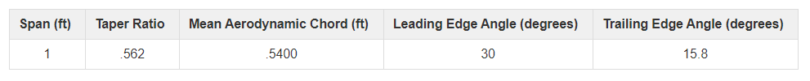](https://courses.ansys.com/wp-content/uploads/2020/05/Table-2.png)**Flow over the Onera M6 wing is transonic and compressible. The wing flow experiences supersonic conditions, a shock, and boundary layer separation. There is no wing twist, with all chords being on the same plane. Therefore, the angle of attack is simply the angle between the free stream and the chord line. There is no side-slip in the simulation. The flow conditions are given below[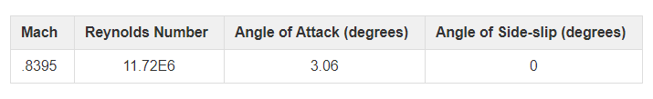](https://courses.ansys.com/wp-content/uploads/2020/05/Table-1.png)Our wing geometry will be a scaled-down version matching the geometry from NASA rather than the experiment available on the linked page. The half span dimension is 1 ft and from there we were able to calculate a scaling factor for the entire wing. More about the geometry creation can be found on the exercises page. The table below describes some key geometries, the leading and trailing edge angles are measured from the vertical.

1. Perform a 3D transonic turbulent CFD Simulation
2. Create a three-dimensional mesh using techniques to strategically refine the mesh
3. Obtain iterative convergence by using recommended solver settings
4. Visualize 3D flow characteristics to gain physical insights
5. Verify and validate simulation results by comparing with experimental data and NASA CFD results

**MATHEMATICAL MODEL**

Our simulation is governed by the continuity, Navier-Stokes (momentum conservation), and energy equations, but since this is turbulent flow, we will be using the Reynolds Averaged version of these equations. We will also be using the Spalart-Allmaras turbulence model to close the Reynolds Averaged equation set. The Spalart-Allmaras turbulence model has been developed for aerospace applications that are wall-bounded and subject to adverse pressure gradients. The Spalart-Allmaras model has only one equation which solves for the kinematic eddy viscosity. We need to solve for the variables of the problem in all cell centers of our mesh. In total, we have six variables to solve for: 3 components of velocity, pressure, temperature, and the kinematic eddy viscosity. The equations are given below.

The Continuity Equation is given by equation 1:

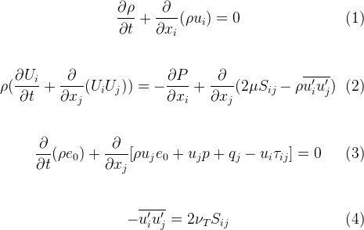

The Reynolds Averaged Navier-Stokes equation is given by equation 2:



The conservation of energy equation is given by equation 3:



The Spalart-Allmaras turbulence model is given by equation 4:



**NUMERICAL SOLUTION PROCEDURE IN ANSYS**

The equations are converted to algebraic equations. It then solves for our six variables at each of the cell centers of our mesh. This means that if we have 300,000 cells, Fluent is going to solve 1.8 million equations to solve the problem.

**Hand Calculations**

In this simulation, we expect to see many flow features in three dimensions. We will be especially interested in the suction peak (low-pressure zone) that forms on the wing and how the size of the suction peak changes spanwise. We will also be looking for a shock along the wing surface as this is transonic flow. We also expect to see trailing edge vortices forming downstream of the wing, due to the interaction of the high and low-pressure zones since this is a finite length wing.

We will also try to predict the lift coefficient of the wing. This calculation will assume that you have seen some of the basics of aerodynamics when it comes to finite wings.

We need to get the lift curve slope for our airfoil assuming that there it is part of an infinite wing. We know that our airfoil is symmetrical, hence at 0 angle of attack, it produces no lift. We find our airfoil (or one that can be closely approximated as our airfoil since it exhibits no lift at a 0 angle of attack). The airfoil that we used is detailed here: [ONERA OA206 Airfoil](http://airfoiltools.com/airfoil/details?airfoil=oa206-il)

We calculate the slope for an infinite wing using its characteristics and find a0 = .0884

Using this, we then can calculate what our lift curve slope for the finite wing will be using the correction for a swept wing. We need to use this correction for a swept wing since the free stream Mach Number is not seen by the entire wing and instead the wing sees a lesser Mach Number, delaying the onset of a shock and increasing the critical Mach Number.

[https://courses.ansys.com/wp-content/uploads/2020/05/LaTeX4646080514134012352.png](https://courses.ansys.com/wp-content/uploads/2020/05/LaTeX4646080514134012352.png)

To use this equation, we must first know the aspect ratio of the wing.

[https://courses.ansys.com/wp-content/uploads/2020/05/LaTeX5917175413394929521.png](https://courses.ansys.com/wp-content/uploads/2020/05/LaTeX5917175413394929521.png)

Where b is the span and S is the planform area of the wing. These two values are either known or easily calculated. We have an aspect ratio of 3.8 for our model.

After we use all of our values, we get a corrected slope a = .0760. For finite wings, we know that the lift curve will be lower than for infinite wings due to 3D effects and this is reflected in our calculation here. Once we know the slope for our finite wing, we can calculate the lift coefficient for the wing.

[https://courses.ansys.com/wp-content/uploads/2020/05/LaTeX4965599677477584135.png](https://courses.ansys.com/wp-content/uploads/2020/05/LaTeX4965599677477584135.png)

Since the airfoil is symmetric, we will say that αL = 0. Then, we get that our lift coefficient is .2328. However, this is for the entire wing (remember that we use only half for our simulation) and the data that we used to calculate this is for low-speed incompressible flows. This means that we need to use a correction for the compressibility at M = .8395.

[https://courses.ansys.com/wp-content/uploads/2020/05/LaTeX5122015702555143540.png](https://courses.ansys.com/wp-content/uploads/2020/05/LaTeX5122015702555143540.png)

Using this correction factor, we get that the lift coefficient for the entire wing will be 0.4284.

This would be for the entire wing and for our half wing, we simply divide by 2 to predict a lift coefficient of .2141.

This is a ballpark estimate of our lift coefficient and we expect that Fluent will give us something comparable but less than what we predict with our hand calculations, due to the presence of the shock on the wing surface.

**Boundary Condition swing surface:**

We will be setting this to the type wall. Basically, a wall boundary condition is setting the velocity there to be 0.

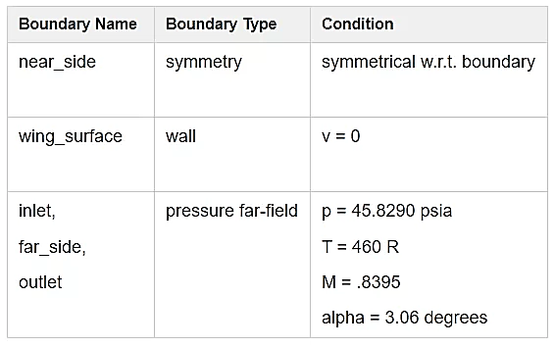**Nearside:**

We will be setting this to type symmetry. This basically means the solution is symmetrical with respect to this plane.

**Inlet, fireside, outlet:**

We will be setting these to type pressure far-field. At these boundaries, we need to specify the pressure, Mach number, temperature, and components of the velocity. This allows for the calculation of the speed of sound, and the velocity direction.



**GEOMETRY**

On the XY Plane → Create Sketch → Draw → Arc by Center

1. Radius = 10 ft
2. Line Connecting Arc Endpoints
3. Revolve Sketch Around Y-Axis
4. Reversed 90 degrees
5. Extrude face along +X axis by 11 ft
6. Create Boolean
7. Target Body = Flow Domain
8. Tool Body = Wing Geometry

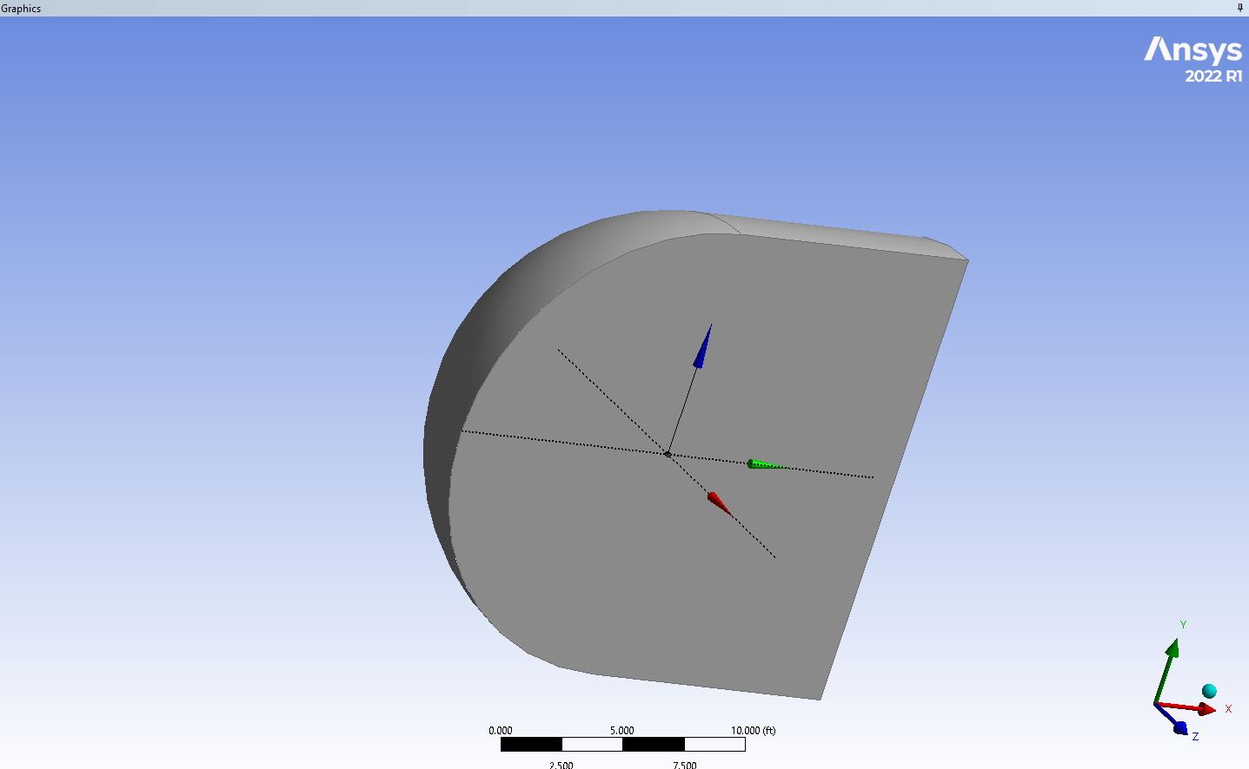

**MESH**

* Change units to US Customary (ft)
* Add Body Sizing
* Mesh → Mesh Control → Sizing
* Select Body of Influence
* Sizing → .3 ft
* Hide Body of Influence Geometry
* Add Face Sizing at Leading Edge
* Mesh → Mesh Control → Sizing
* Select leading edge face
* Element Size = .01 ft
* Repeat (3) for Trailing-Edge Face
* Element Size = .01 ft
* Repeat (3) for Middle Face
* Element Size = .03 ft
* Repeat (3) for Bottom Face
* Element Size = .03 ft
* Add Inflation Layers
* Total Thickness = .006 ft
* Post Inflation Algorithm

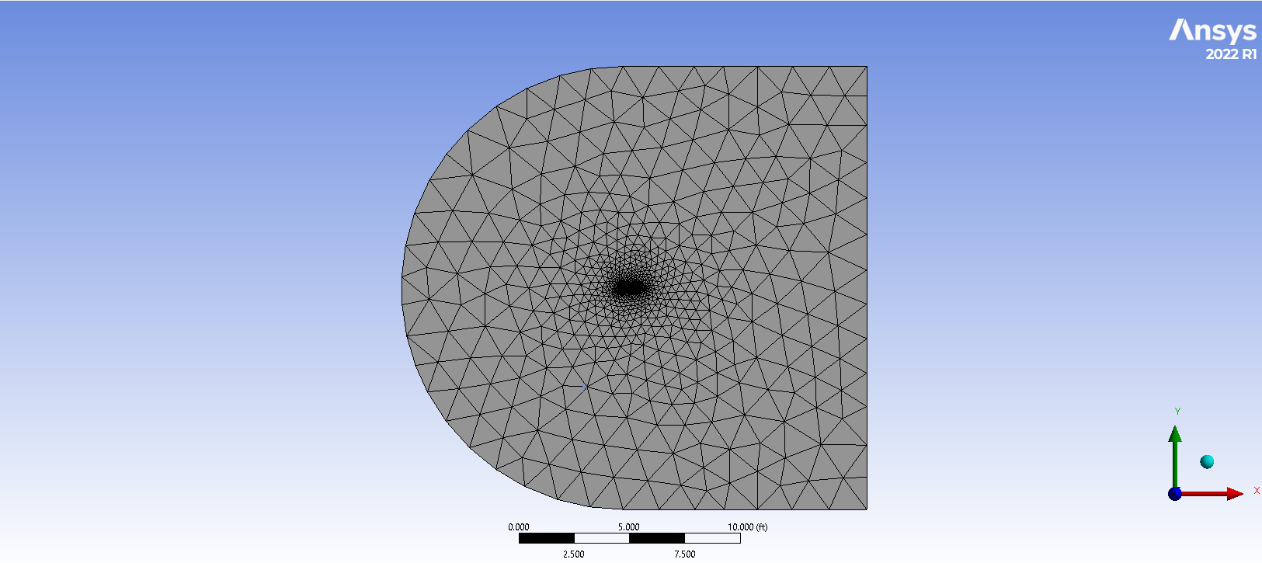

**BOUNDARY CONDITIONS**

1. Far Side → Pressure Far-Field
2. Pressure = 45.829 psia
3. Mach Number = .8395
4. Angle of Attack = 3.06 deg
5. x-component: 0.9986
6. y-component: 0.0534
7. Temperature = 460 R
8. Repeat for Inlet and Outlet
9. Near Side → Symmetry
10. Wing Surface and Wing tip → Wall

**SOLUTION:**

**Converence**

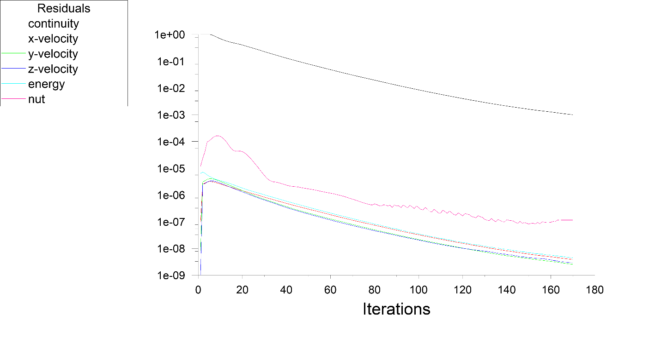

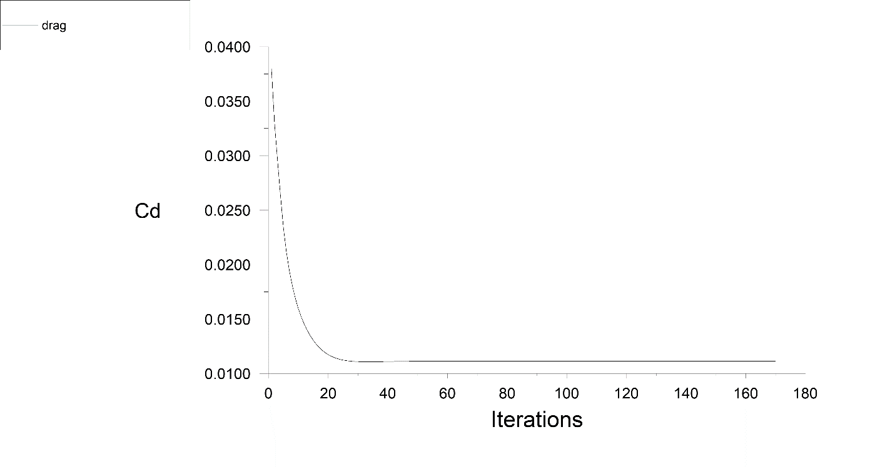

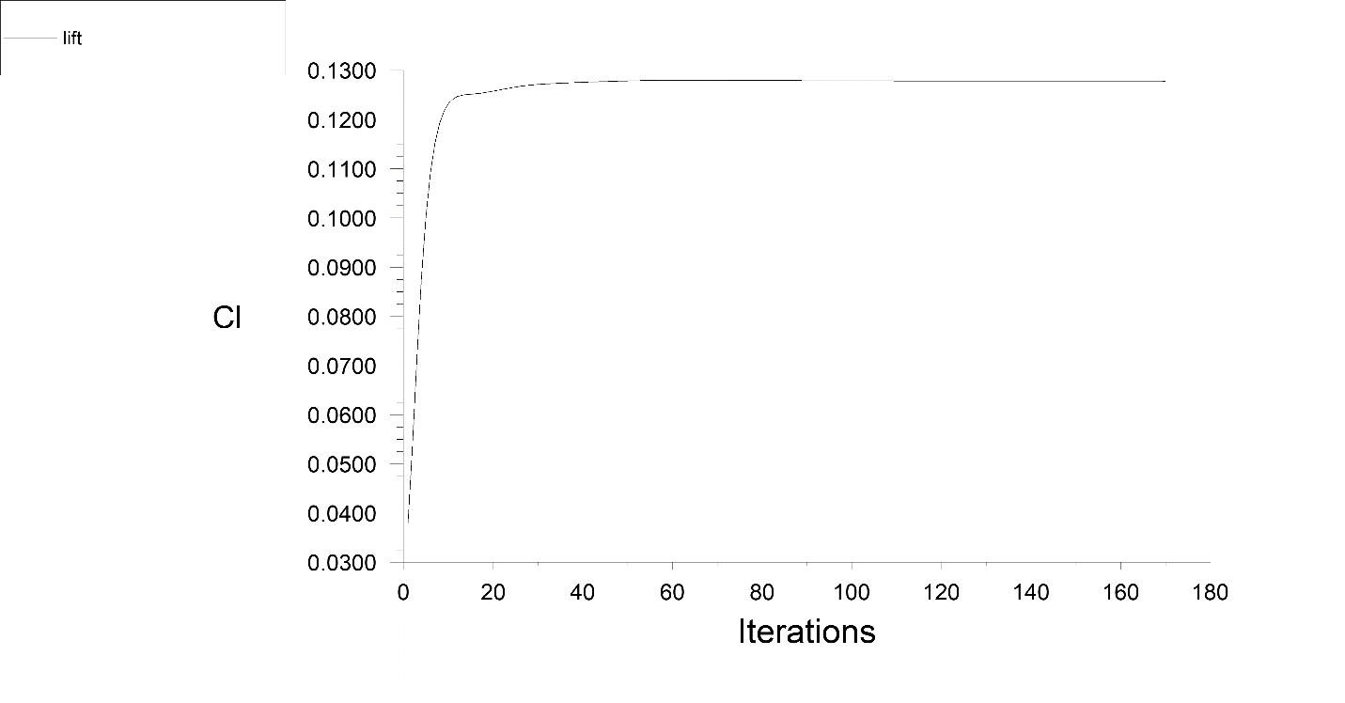

Pressure:

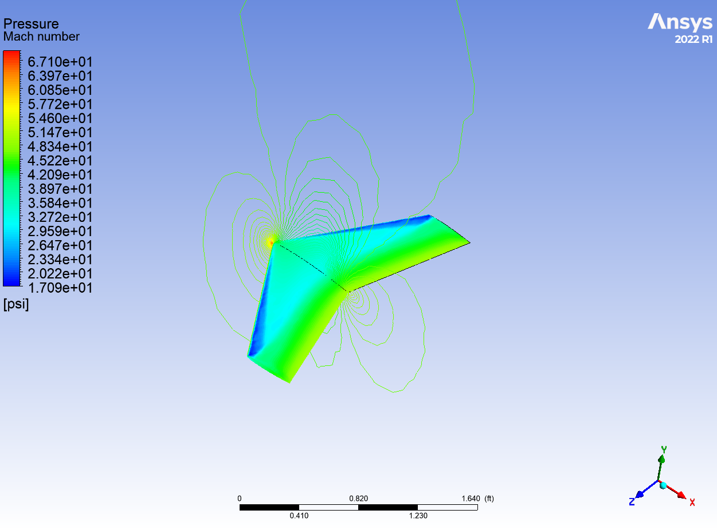

Pressure vector:

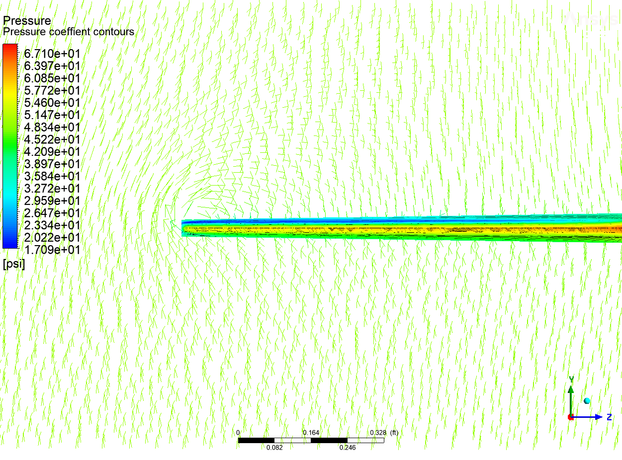

vortex

**Comparison with NASA CFD**

We compare the drag coefficient and lift coefficient to those from NASA's WIND simulation:



For refined mesh 2 the grid was changed from coarse relevance center to medium relevance center with the leading edge face and trailing edge face cell sizes further refined. The middle face on the top wing surface and the bottom wing surface sizings were also refined. The body of influence's size was changed to be .0075 ft.

Note: You can improve the results by accounting for the variation in the viscosity of air with temperature using the Sutherland model.

**REFERENCES**

Comparison data was obtained from NASA's Glenn Research Center validation archive:

1. Slater, John W. "ONERA M6 Wing Study #1." ONERA M6 Wing. NPARC, n.d. Web.